website and game report

Bryan Chontasi

M00527172

Introduction

Having planned the structure of my game, I will be explaining how I have come to develop and construct Block+.

In order for the game to function, I used HTML, JavaScript and CSS. The design of this website is based on the proposal that I previously delivered.

The website contains five pages: index.html, loginAndRegister.html, game.html, contactUs.html and instructions.html

The game:

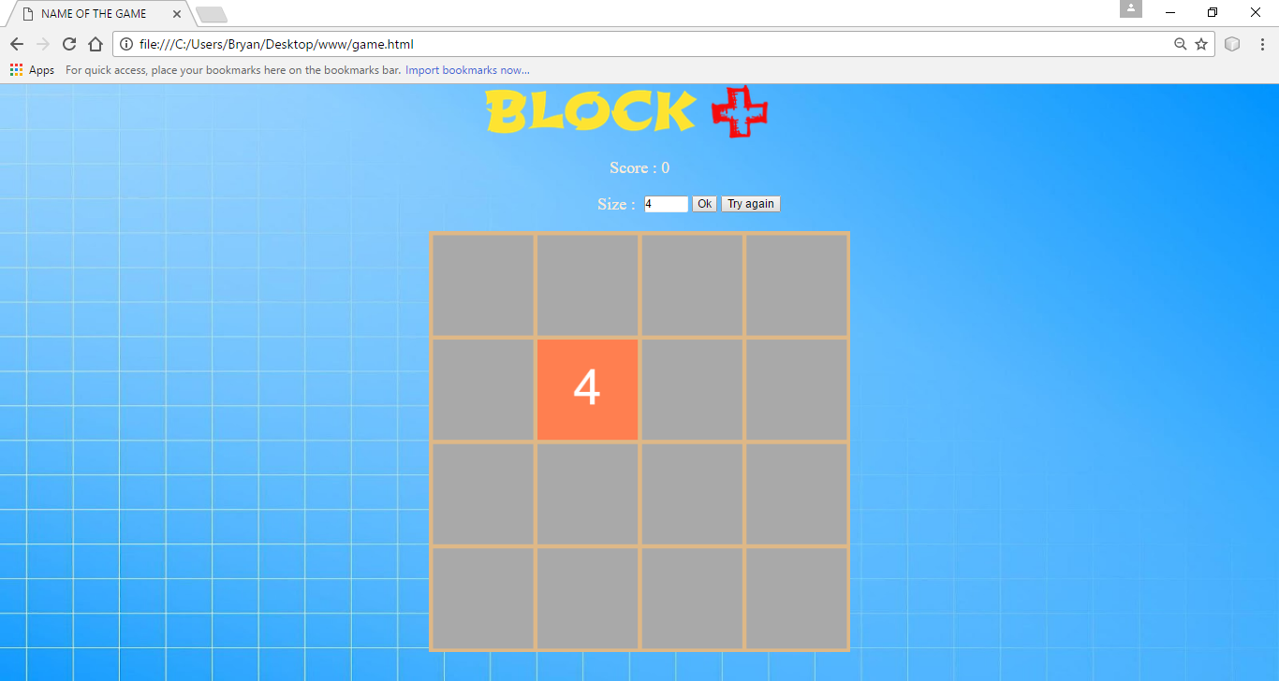

The main purpose of the game is to keep joining two same digit squares together with the objective of gaining the maximum sum possible which is reflected on the score status as well as the top score list, situated on a different page.

Once you commence the game, you will find two randomly situated squares labelled 2, when you join two of the same numbers, they merge and create a new number that is the addition of the two numbers. For example:

2+2=4, 4+4=8, 8+8=16, 16+16=32, 32+32=64, 64+64=128, 128+128=256 256+256=512, 512+512=1024, 1024+1024=2048….

To move the numbers in the grid, you have to click a direction (up, down, left and right).

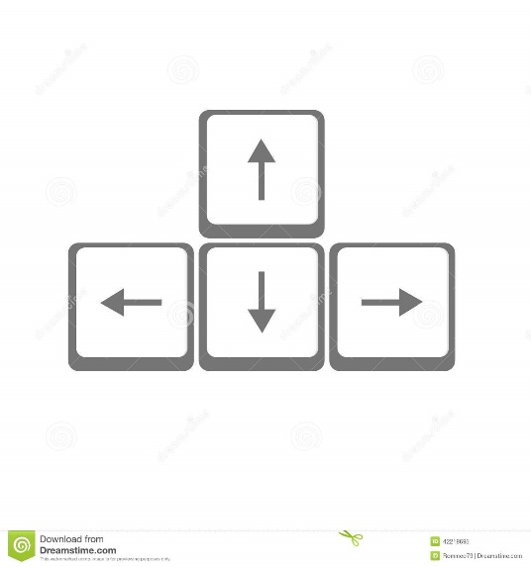

**Design**:

As you are able to see, in the screenshot I used a blue image as a background with the logo of my game. Top centre of the page.

The design of my game has a size of 4, it consists of a 4x4 grid with 16 squares which can be moved (left, right, up or down). On the top right of the grid you are able to see your score, and also there is a button to restart the game labelled “Try again”. You can change the size of the grid by changing the number that is below the score.

The game allows 2x2, 3x3, 4x4, 5x5, 6x6, and 7x7 grids. Here there is an example with a size of 7:

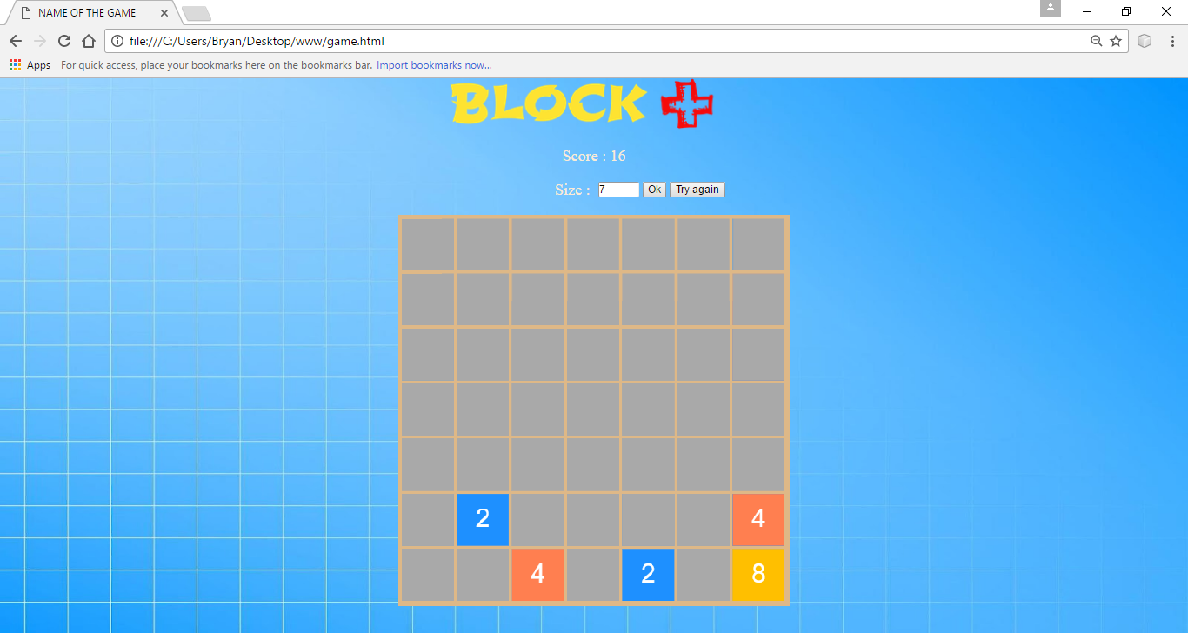

The color of the tiles depend on the number it is labelled by. For example; in the image above, tile number 2 will always be blue and number 4 will be orange.

Index page:

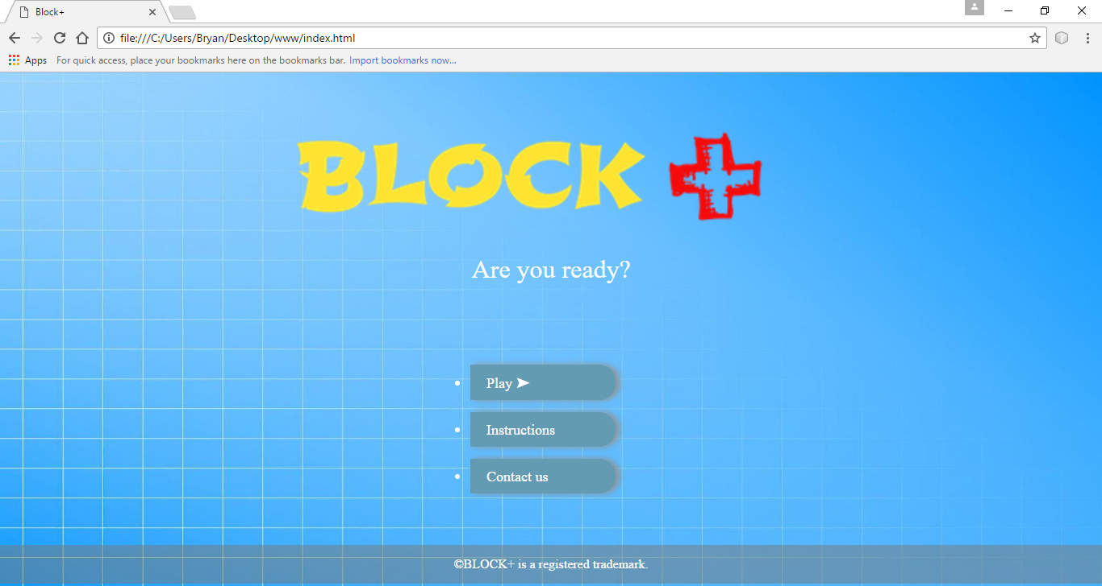

On this page you can see the logo and a message to the user in the middle of the screen.

It has an interactive menu with 3 buttons (play, instructions and contact us) that will take you to their respective pages. On the bottom of the page there is a footer with a message of copyright.

Log in and register page:

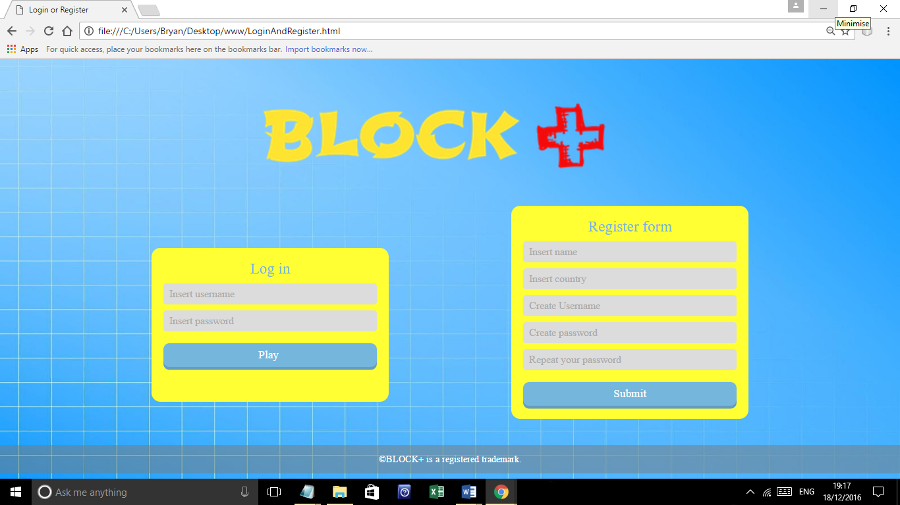

On the log-in page you can access your account by entering your username and password in order to play, also you can fill the register form to make a new account in order to play. To return to the index page you can just simply click the game logo.

The register form and the log in have validation, if you do not have an account and you click on “play” the following message will appear to you:

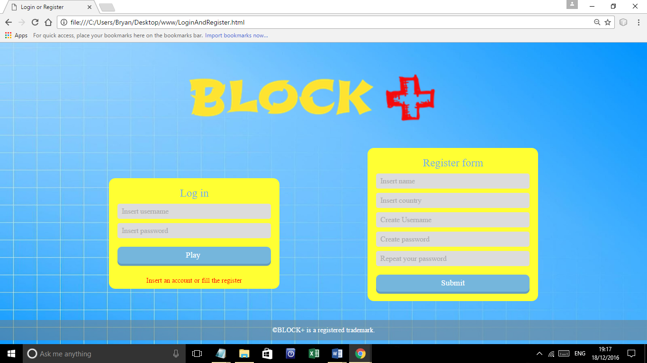

Also, if you click on submit without filling in the register form, you will receive an alert message like this one:

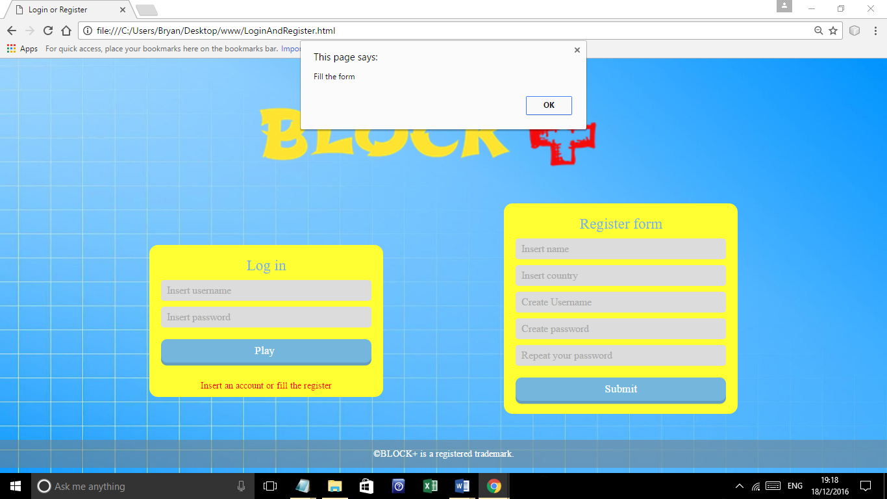

Instructions page

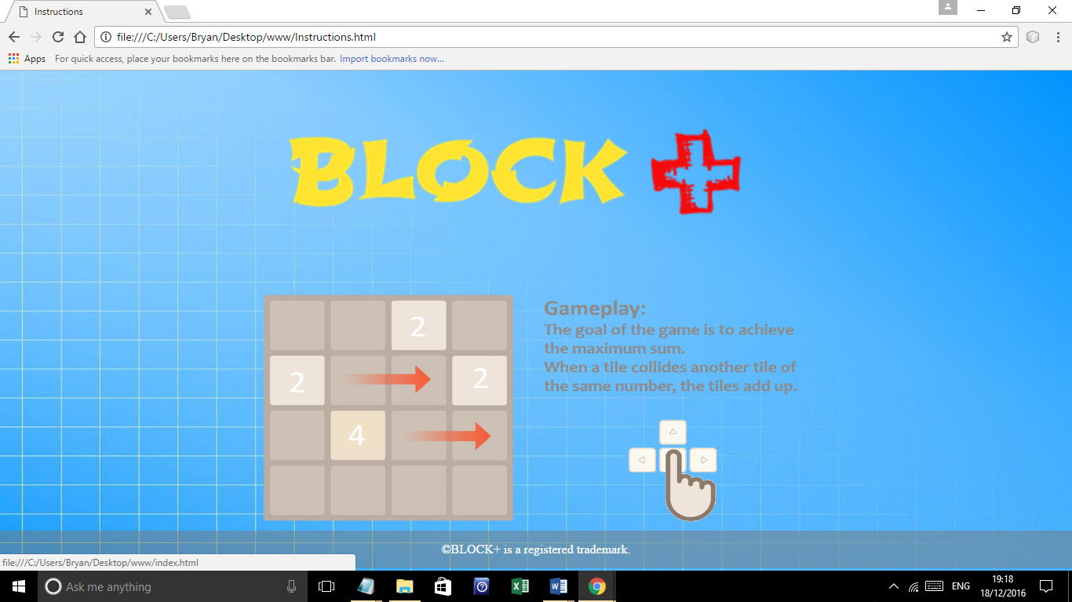

On this page you can see the logo and the instructions of the game in the middle of the screen, if you click on the instructions image or on the logo you will go back to the index page.

Contact us page

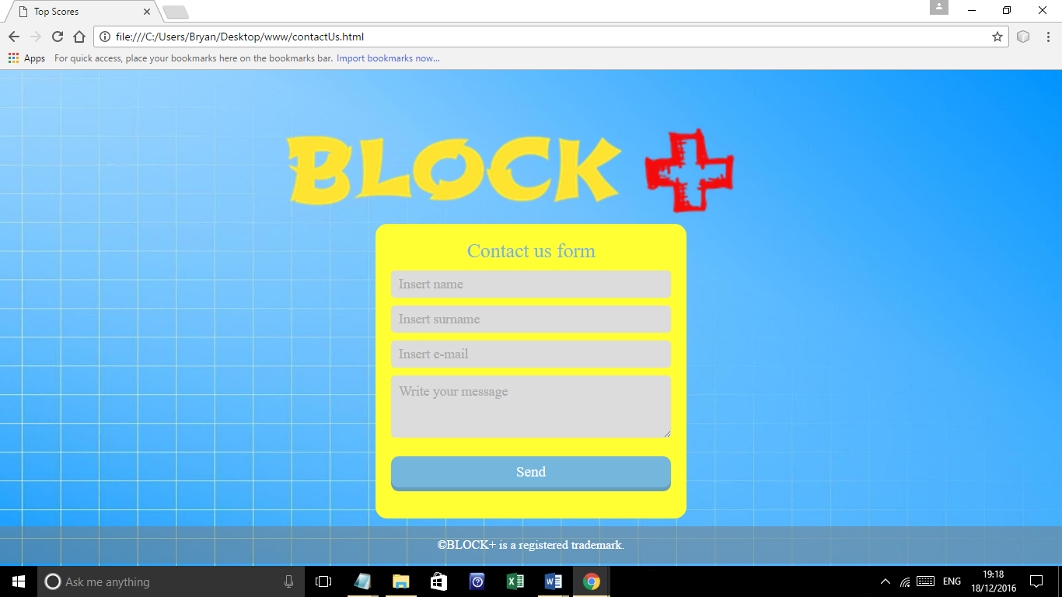

On this page there is also the logo in the middle of the page with the contact us form.

The form includes Name, Surname, E-mail, a text area (where the user can write his comments) and the button to Send.



If you forget a to fill a cell in the form or leave it blank, you will get an alert message:

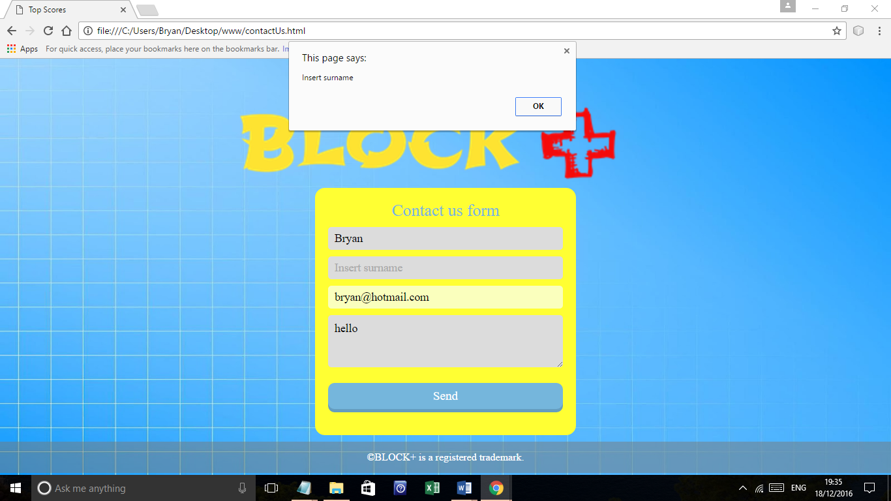

Or if you do not insert a valid email you will receive this message:

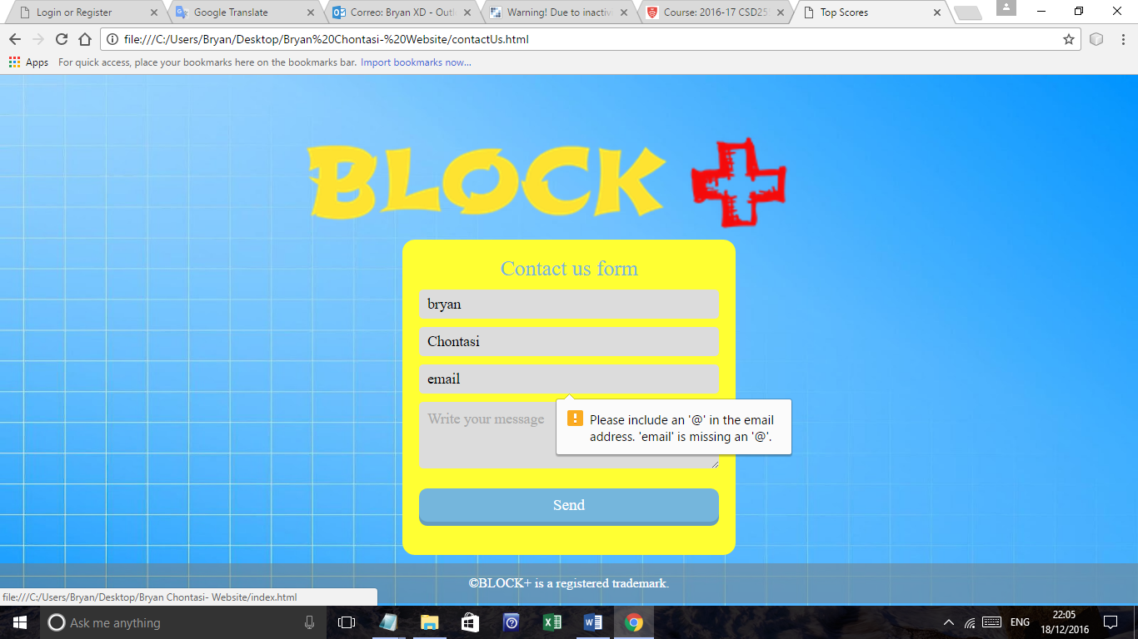

Conclusion:

I enjoyed greatly every aspect of this project as I have further developed HTML, CSS, PHP, and JavaScript language skills. Following completion, my confidence and ability when designing and creating websites or applications in JavaScript have advanced as practice has enabled me to. There are several things in the previous proposal report that was not added to the web page and I would like to continue learning using these languages so that in future practice I can do everything that I initially propose.